**Date:** 5/4/16

**Project Name:** Next Gen Parents Feature

**Submitted By**: MacKenzie Sherman

(**Kids Team:** Matt Sherman, Shawna Seeger, and Eric Voris)

**Summary**

Create a way for Parents to become familiar with Kids content. Provide this content in a simple to use way.

**Project Scope (IT/CT)**

* Add tab/section for “Parents” on the CCV App
* Under the Parents tab/section would be…
  + **Early Kids (Birth- 1st)**\* inner-office terms, possible change of name for this feature
    - Weekend Messages
    - Synopsis of content
    - Bible passages
    - Questions to continue the conversations at home
    - The “Big Question” of the weekend
    - Kids bible- (YouVersion)
    - Weekend Printable
      * Motions from the weekend
      * Worksheets
      * Coloring pages
    - Song Downloads
    - Parent Recommendations
      * Bibles
      * Books
      * Parenting Books
  + **Later Kids (2nd-6th)** *inner-office terms, possible change of name for this feature
    - Weekend Messages and Intro videos (Separate uploads)
    - Synopsis of content
    - Bible passages
    - Questions to continue the conversations at home
    - The Main Point of the weekend
    - Song Downloads
  + **Special Needs Ministry** 
    - Resources
    - (Checking with Laura about SN ideas)
* Reports
  + Which videos are being watched (Wistia?)
  + Parents that access this Function on a weekly basis (for the first 3 months, then a quarterly report

**Schedule**

* Active the Weekend of July 23rd and 24th for the “I Love My Church” series. (This is the NextGen weekend) **\*\*Check Dates**

**Level of Effort**

* Involves: AM Dev Team; IT Team, Creative Services Team (Web), Campus Teams

**ROCK UPDATES:**

* N/A

**APP UPDATES:**

* Parents function off of the CCV App

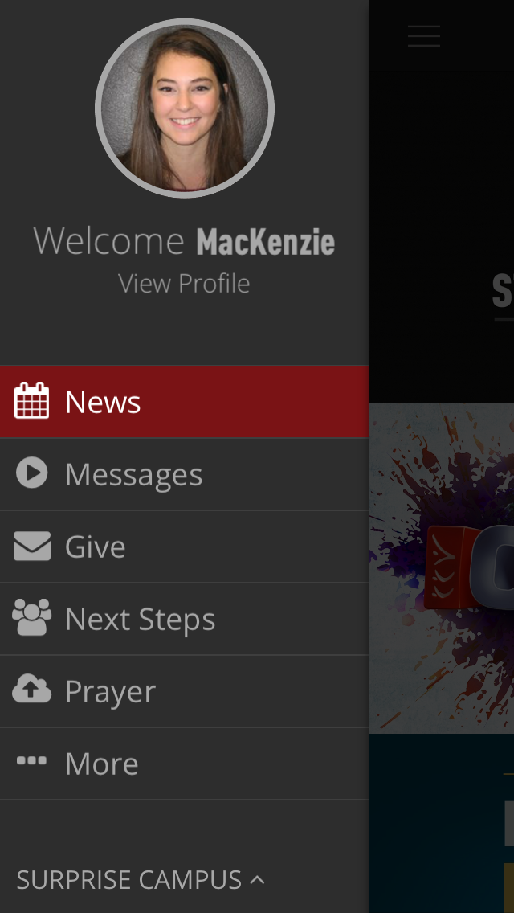

Parents

**Web Updates:**

* Updating the Website for there to be a “Parents” section/page of some sort to reflect the app

**Editing**

* Weekly Content

**Roster Updates:**

* N/A